1.Define Power BI and What are the key components of the Power BI ecosystem? Briefly
explain:
● Power BI Desktop
● Power BI Service
● Power BI Mobile
● Power BI Gateway
Answer
Power BI is a business intelligence (BI) and data visualization tool developed by Microsoft that helps users connect to data, transform it, analyze it, and create interactive reports and dashboards for better decision-making.

Key Components of the Power BI Ecosystem

1. Power BI Desktop
Power BI Desktop is a Windows-based application used to create reports.
- Connects to multiple data sources (Excel, SQL Server, APIs, etc.)
- Allows data cleaning and transformation using Power Query
- Supports data modeling using DAX (Data Analysis Expressions)
- Used to design interactive reports and visuals
- Reports created here are published to Power BI Service

2. Power BI Service (PowerBI.com)
Power BI Service is a cloud-based platform used for sharing, collaboration, and report consumption.
- Hosts published reports and dashboards
- Enables sharing reports with users and teams
- Supports real-time dashboards and scheduled data refresh
- Provides role-level security (RLS)
- Integrates with Microsoft Teams, SharePoint, and Excel

3. Power BI Mobile
Power BI Mobile is a mobile application available on Android, iOS, and Windows devices.
- Allows users to access dashboards and reports on mobile devices
- Provides alerts for data changes
- Optimized for touch and mobile viewing
- Enables decision-making on the go

4. Power BI Gateway
Power BI Gateway is a bridge between on-premises data sources and the Power BI Service.
- Enables secure data access from on-premise databases
- Supports scheduled refresh and live queries
- Ensures data does not need to be moved to the cloud
- Essential for organizations using local servers
2. Compare the following Power BI visuals:
● Pie Chart vs Donut Chart
● Bar Chart vs Column Chart
When would you prefer one over the other? Give one example for each pair
Answer

1. Pie Chart vs Donut Chart
Pie Chart
- Shows parts of a whole
- Simple and easy to interpret
- Displays data as slices
Donut Chart
- Similar to pie chart but with a hollow center
- Allows space for total or labels
- Better visual appeal when showing totals
When to Prefer
- Use Pie Chart for a few categories with clear proportions
- Use Donut Chart when you want to highlight total values in the center
Example
- Pie Chart: Percentage share of different crops in total agricultural output
- Donut Chart: Percentage-wise department-wise expenditure with total budget shown in center

2. Bar Chart vs Column Chart
Bar Chart
- Horizontal bars
- Best for long category names
- Easy comparison across categories
Column Chart
- Vertical bars
- Best for time-based data
- Shows trends clearly
When to Prefer
- Use Bar Chart for comparing many categories
- Use Column Chart for comparing data over time periods
Example
- Bar Chart: Population by states of India
- Column Chart: Monthly sales data of a company

Question 3 :
Explain the significance of:
● Star schema vs Snowflake schema
● Primary key vs Foreign key in relationships (Power BI)
Why is cardinality important?
Answer

Star Schema vs Snowflake Schema – Significance
Star Schema
- Simple structure with one fact table connected to dimension tables
- Faster query performance
- Easy to understand and use in Power BI
Snowflake Schema
- Dimension tables are further normalized into sub-dimensions
- Saves storage space
- More complex and slower than star schema
Significance
- Star schema is preferred in Power BI for better performance and simpler modeling
- Snowflake schema is used when data normalization is required

Primary Key vs Foreign Key (in Power BI Relationships)
Primary Key
- Uniquely identifies each record in a table
- No duplicate or null values
Foreign Key
- References the primary key of another table
- Used to create relationships between tables
Significance
- Ensures correct data linking and accurate aggregations in Power BI

Why Cardinality Is Important
- Cardinality defines the relationship type (one-to-one, one-to-many, many-to-many)
- Ensures accurate filtering and aggregation of data
- Incorrect cardinality can cause wrong totals and duplicate counts
- Helps Power BI optimize performance and data accuracy
Question 4 :
Differentiate between:
● Calculated column vs Measure
Also, define Row context and Filter context with simple examples
Answer

Calculated Column vs Measure
Calculated Column
- Calculated row by row
- Stored physically in the table
- Increases model size
- Used for categorization and slicing
Measure
- Calculated at query time
- Not stored in the table
- Uses filter context
- Used for aggregations and KPIs

Row Context
- Calculation happens for each row individually
Example:
Total Price = Quantity × Unit Price (calculated for every row in a sales table)

Filter Context
- Calculation happens based on applied filters (visuals, slicers, filters)
Example:
Total Sales = SUM(Sales[Amount])
Filtered by Year = 2024 or Region = South

Question 5
What is the difference between a report and a dashboard in Power BI?
Answer

Difference between Report and Dashboard in Power BI
Report
- A report is a collection of multiple pages with visuals
- Created in Power BI Desktop
- Can use data from one dataset
- Supports detailed analysis and interactions (filters, slicers)
- Used for in-depth data exploration
Dashboard
- A dashboard is a single-page canvas
- Created in Power BI Service
- Can combine visuals from multiple reports/datasets
- Provides a high-level summary
- Used for quick monitoring and decision-making

Question 6 :
Using the Sample Superstore dataset:
● Create a Clustered Bar Chart to display Total Sales by Sub-Category
● Create a Donut Chart for Sales % by Region Provide screenshots of both visuals.
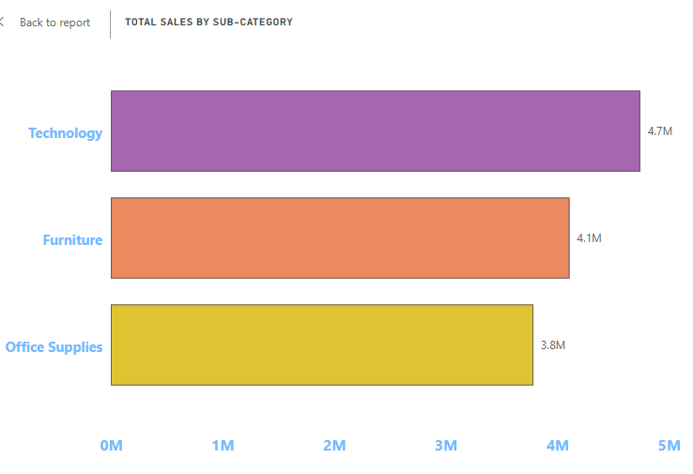

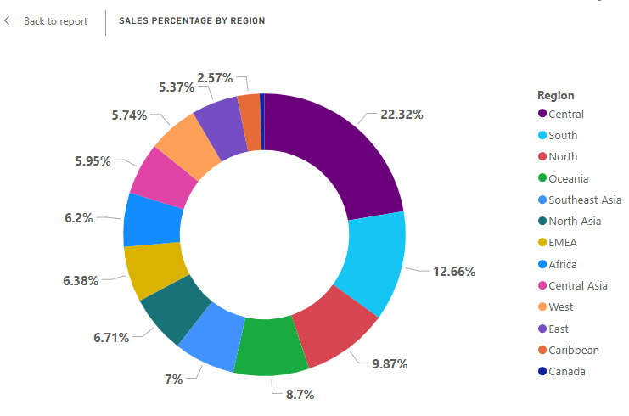

Question 7 :
Write and apply the following measures:
● Total Profit = SUM([Profit])
● Average Discount = AVERAGE([Discount])
Display both in a KPI Card, and use a Line Chart to show profit trend over
months.
Add visuals and DAX formulas.

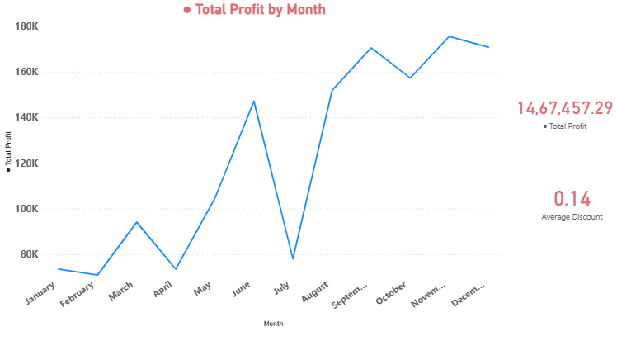

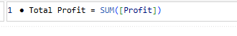
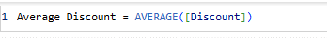

Question 8
Implement a DAX measure that calculates the percentage of total sales by product category.

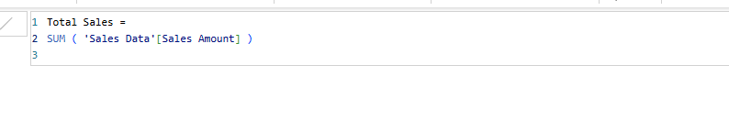

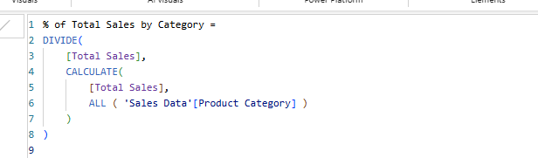

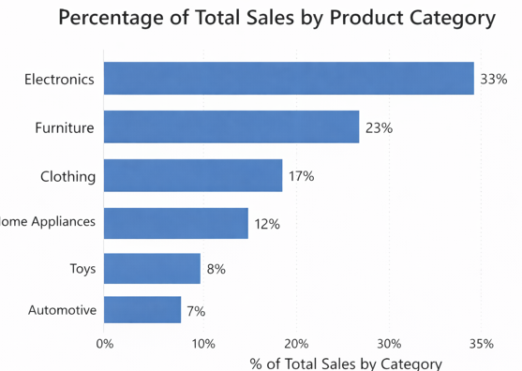

Question 9 :
● Create a DAX Measure for Total Profit
● Use it in a Waterfall Chart to analyze how different Sub-Categories contribute to
overall profit
● Add a Slicer for Region to filter the visual
● Write brief business insights (4–5 lines) from the chart and provide 2–3 data-driven
recommendations to improve profit.

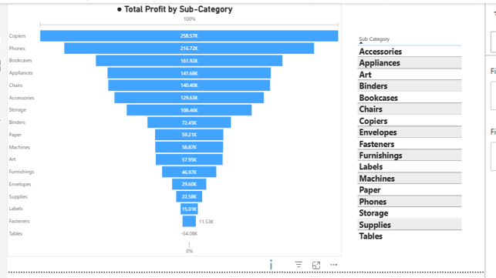

Question 10
Build a one-page Power BI dashboard that answers:
1. Are users maintaining a balanced lifestyle (Steps, Sleep, Calories)
2. What lifestyle patterns (Smoking, Alcohol, BMI, etc.) indicate heart disease risk?
3. Is there any visible relationship between Sleep and Physical Activity?
4. How does BMI vary across Age Groups and Genders?
5. What is the impact of smoking and alcohol on heart rate and blood pressure?
6. Segment people based on their health activity to suggest lifestyle changes

